Welcome to AWS Cloud Practitioner Essentials:

Welcome to AWS Cloud Practitioner Essentials
In this first part of the course, you’ll learn the basics of cloud computing and how the cloud changes the way businesses work — making them more flexible, efficient, and innovative.

how the client-server model works in this analogy:
The client makes a request to the server, and the server processes the request and sends back the response.

What is Cloud Computing?
- Define cloud computing.
- Describe and differentiate between cloud deployment types.

Defining cloud computing
On-demand delivery of IT resources over the internet with pay-as-you-go-pricing.
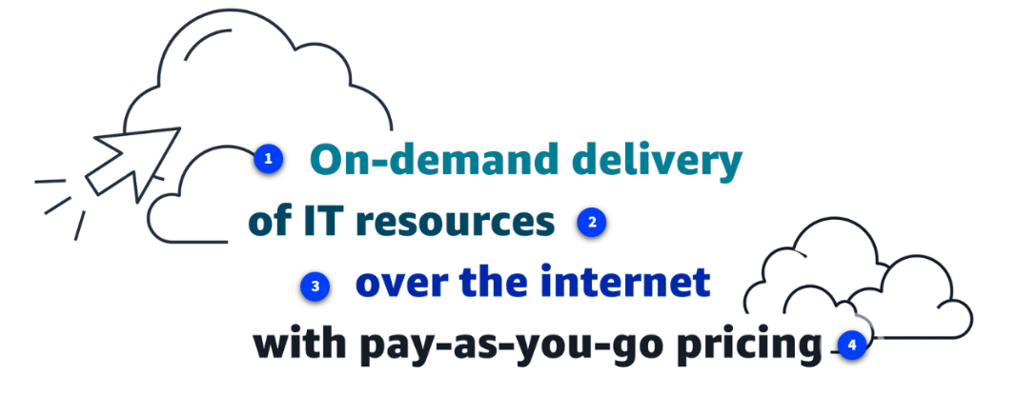

On-demand delivery
On-demand delivery means that customers can access computing resources, such as storage or compute power, within seconds and as needed. Users can scale their resource usage up or down based on current requirements without lengthy provisioning processes.
- On-demand delivery means you can get computing resources (like storage or servers) instantly whenever you need them.
- You can increase or decrease the resources anytime — no waiting or long setup process needed.

of IT resources
The of IT resources aspect highlights the wide array of information technology assets in the cloud-computing space. These resources include servers, storage solutions, databases, networking components, artificial intelligence and machine learning (AI/ML) tools, and more. Customers can use these resources to build, deploy, and manage applications and services through the cloud infrastructure.
- In cloud computing, IT resources include things like servers, storage, databases, networking, and AI/ML tools.
- Customers can use these resources to build, run, and manage applications easily in the cloud.

over the internet
Over the internet signifies that cloud computing delivers IT resources through internet connectivity. This means that users access and use these resources through web-based services rather than maintaining local hardware or software.
The internet acts as the conduit, which provides remote access to compute power, storage, and applications from anywhere in the world.
- Cloud computing delivers IT resources through the internet.
- This means users can access servers, storage, and applications online, without needing their own hardware or software.
- You can use these resources from anywhere, anytime using an internet connection.

with pay-as-you-go-pricing
Flexible pricing is a fundamental economic aspect of cloud computing. Users pay only for the resources they actually consume, rather than committing to fixed, long-term contracts. This usage-based pricing model offers cost efficiency and financial flexibility.
- In cloud computing, you pay only for what you use — just like electricity or water.
- There’s no need for long-term contracts or paying for unused capacity.
- This makes cloud costs flexible and efficient.

Cloud deployment types:
You can deploy cloud resources in multiple ways: cloud, on-premises, and hybrid. Each type offers unique benefits and considerations, and exploring these options can help you make informed decisions about your cloud strategy.
You can deploy resources in different ways:
- Cloud – Fully on the cloud, managed by a provider.
- On-Premises – Fully on your own local servers.
- Hybrid – A mix of cloud and on-premises.
Each approach has different benefits and considerations, helping you choose the best strategy for your needs.

Cloud
In a cloud-based deployment model, you have the flexibility to migrate your existing resources to the cloud, design and build new applications within the cloud environment, or use a combination of both.
In a cloud deployment, you can:
- Move existing resources to the cloud,
- Build new applications directly in the cloud, or
- Do both together.

For instance, a company might migrate data resources to the cloud, then develop an application comprised of virtual servers, databases, and networking components entirely hosted in the cloud.
For example, a company can:
- Move data to the cloud, and
- Create an application using virtual servers, databases, and networking — all hosted in the cloud.

On-premises
Deploying resources on premises using virtualization and resource management tools does not provide many of the benefits of cloud computing. However, it is sometimes sought for its ability to provide dedicated resources and low latency.
In most cases this deployment model is the same as legacy IT infrastructure while using application management and virtualization technologies to try increasing resource utilization.
- Resources are hosted locally using your own servers and virtualization tools.
- Offers dedicated resources and low latency.
- Provides fewer cloud benefits, mostly similar to traditional IT infrastructure, but with slightly better resource management using virtualization.

- On-premises means that all the IT resources — servers, storage, networking, databases, applications — are kept and managed inside your own office or data center instead of in the cloud.

Hybrid
In a hybrid deployment, cloud-based resources and on-premises infrastructure work together. This approach is ideal for situations where legacy applications must remain on premises due to maintenance preferences or regulatory requirements.

For instance, a company might choose to retain certain regulated legacy applications on-premises while using cloud services for advanced data processing and analytics.
Multi-cloud deployments can also be considered hybrid deployments.

Hybrid deployment combines cloud and on-premises resources so they work together.
- On-premises: Keep legacy apps or sensitive data on local servers.
- Cloud: Run new applications, handle high traffic, or scale resources quickly.

Benefits of the AWS Cloud: Key benefits of the AWS Cloud
The six key benefits of the AWS Cloud are as follows.
1. Trade fixed expense for variable expense
By using the AWS Cloud, businesses can transition from fixed investments to variable costs. With variable costs, customer expenses are better aligned with actual usage, thus creating more financial flexibility.
- With AWS, businesses pay only for what they use instead of buying expensive servers upfront.

2. Benefit from massive economies of scale
Like buying a product in bulk can result in lower prices per unit, the vast global infrastructure of AWS can result in lower costs for customers. This means that AWS can be used by many organizations, from small startups to major corporations. Businesses big and small can access advanced technologies that were previously only accessible to large enterprises.

AWS’s huge global infrastructure lets them offer lower costs to customers, similar to buying in bulk.
- Small and large businesses can access advanced technologies.
- Even startups can use tools that used to be available only to big companies.

3. Stop guessing capacity
Customers can dynamically scale AWS Cloud resources up or down based on real-time demand. This means businesses can achieve optimal performance without provisioning more or less infrastructure than they need.

With AWS, businesses can scale resources up or down automatically based on real-time demand.
- No need to guess how much infrastructure you’ll need.
- Ensures optimal performance without wasting money.
4. Increase speed and agility
With the cloud, businesses can rapidly deploy applications and services, accelerating time to market and facilitating quicker responses to changing business needs and market conditions.

The cloud lets businesses launch applications and services quickly.
- Speeds up time to market.
- Helps respond faster to changing business needs or market conditions.

5. Stop spending money to run and maintain data centers
The AWS Cloud eliminates the need for businesses to invest in physical data centers. This means customers aren't required to spend time and money on utilities and ongoing maintenance. With AWS taking care of the physical infrastructure of the cloud, customer resources can be reallocated to more strategic initiatives.

With AWS, businesses don’t need to buy or maintain physical data centers.
- No spending on servers, electricity, or maintenance.
- Resources and money can be used for more important business projects.

6. Go global in minutes
Businesses don't need to set up their own infrastructure to expand internationally. AWS provides a robust global infrastructure that customers can use to deploy applications and services across multiple areas in minutes.

With AWS, businesses can expand internationally without building their own infrastructure.
- Deploy applications and services across multiple regions in minutes.
- Reach customers anywhere in the world quickly and easily.

Introduction to AWS Global Infrastructure
- Define AWS Regions and Availability Zones.
- Explain the benefits of high availability and fault tolerance.

AWS Regions and Availability Zones
AWS Global Infrastructure consists of physical locations around the world that contain groups of data centers.
AWS has physical locations worldwide made up of groups of data centers.
- These locations form the global infrastructure that powers AWS services.

AWS Regions
AWS Regions are physical locations around the world that contain groups of data centers. These groups of data centers are called Availability Zones. Each AWS Region consists of a minimum of three physically separate Availability Zones within a geographic area.

- Regions are physical locations around the world containing groups of data centers.
- These groups of data centers are called Availability Zones (AZs).
- Each Region has at least three separate AZs within the same geographic area.

Availability Zones
An Availability Zone consists of one or more data centers with redundant power, networking, and connectivity. Regions and Availability Zones are designed to provide low-latency, fault-tolerant access to services for users within a given area.
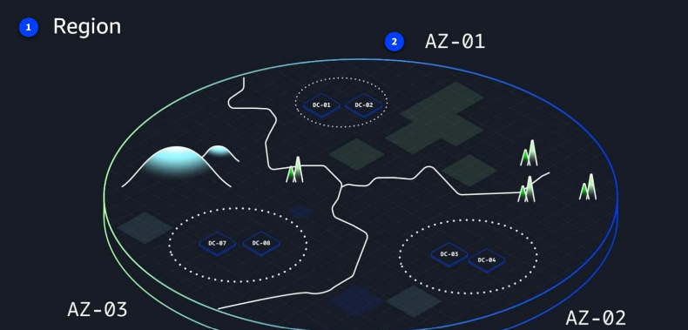

Achieving high availability with AWS Global Infrastructure
AWS infrastructure is designed with high availability and fault tolerance in mind. Availability Zones (AZs) are configured as isolated resources, and they are each equipped with independent power, networking, and connectivity.

It's recommended to distribute your resources across multiple AZs. That way, if one AZ encounters an outage, your business applications will continue to operate without interruption. With this approach of redundancy and resource isolation, AWS customers can achieve the benefits of high availability and fault tolerance.
Note: AWS provides multiple data centers across different geographic regions so your website can remain operational even if one location faces issues.
High Availability with AWS Global Infrastructure
- AWS is built for high availability and fault tolerance.
- Availability Zones (AZs) are isolated with their own power, networking, and connectivity.
- Distribute resources across multiple AZs so if one AZ fails, applications keep running.
- This redundancy and isolation ensures continuous operation and reliable performance.
    - Redundancy: Having multiple copies or backup systems of important components (like servers, databases, or network connections).
    - Isolation: Keeping components separate so that a problem in one area doesn’t affect others.

The AWS Shared Responsibility Model
- Describe and differentiate between customer responsibilities, AWS responsibilities, and shared responsibilities in the AWS Cloud.
- Describe the components of the AWS Shared Responsibility Model.

The AWS Shared Responsibility Model is a concept designed to help AWS and customers work together to create a secure, functional cloud environment.
- Secure – protected from threats.
- Functional – performs correctly, with applications and services running smoothly.

Components of the AWS Shared Responsibility Model
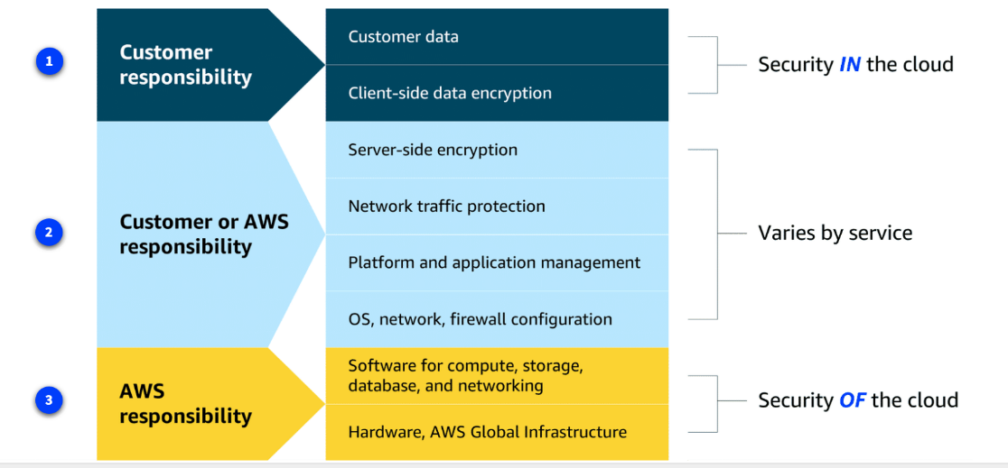

Customer responsibilities
Customers are responsible for managing security requirements for their data, including which data they store on AWS and who has access to that data. Customers also control how access to the data is granted, managed, and revoked.
Additionally, customers are responsible for client-side encryption.
- Manage data security: Decide what data to store on AWS and who can access it.
- Control access: Grant, manage, and revoke permissions for users.
- Client-side encryption: Handle encryption before sending data to AWS if needed.

Shared responsibilities
Depending on the service used, responsibilities might shift between the customer and AWS. Components such as server-side encryption, network traffic protection, platform and application management, and OS, network, and firewall configuration vary by service in terms of who is responsible for these items. As you learn more about different types of services, you will see specific examples of how these elements are divided between the customer and AWS.
- Responsibility changes depending on the AWS service you use.
- Some tasks, like server-side encryption, network protection, application management, and firewall setup, may be handled by AWS, the customer, or both.
AWS responsibilities
AWS is responsible for protecting the infrastructure that runs all of the services offered in the AWS Cloud. This infrastructure is composed of the hardware, software, networking, and facilities that run AWS Cloud services.
- AWS protects the infrastructure that powers its cloud services.
- This includes hardware, software, networking, and data centers.
- Essentially, AWS is responsible for the security of the cloud itself, while customers handle what they put in the cloud.

Applying Cloud Concepts to Real Life Use Cases
- Explain how fundamental cloud concepts, such as the AWS Global Infrastructure and AWS Shared Responsibility Model, work together to form real-world business solutions.
Cloud in real life: Infrastructure and shared responsibility
- Example: A global e-commerce company deploys resources across multiple Regions and Availability Zones.
- This setup shows benefits of redundancy, high availability, and fault tolerance, and how AWS and the company share responsibilities.

Ecommerce company expansion
- The company is based in Seattle, USA and wants to reach customers worldwide.
- Data and servers far from customers cause longer latency (slower performance).
- To fix this, the company uses multiple global AWS Regions to deliver faster, better service to customers everywhere.

Global expansion one: Ireland
The company deploys resources to the eu-west-1 Region in Ireland. Deploying in multiple Regions increases high availability. The company increases fault-tolerance and high availability even more by deploying to two Availability Zones in this Region.

The company does not need to worry about securing the data center in Ireland because securing the physical infrastructure is an AWS responsibility. The company can instead focus on securing and encrypting their data within their cloud resources.
- The company deploys resources to Ireland (eu-west-1 Region).
- Using multiple Regions improves high availability.
- Deploying in two Availability Zones in Ireland increases fault tolerance and reliability.
- AWS secures the data center, so the company focuses on securing and encrypting their own data.
Global expansion two: Singapore
The company has a significant customer base in Asia, too. So, they deploy resources to the ap-southwest-1 AWS Region in Singapore.
Rather than having to set up physical infrastructure at an international scale, which can take months or years, the company used AWS to deploy global operations within a matter of minutes.
- The company deploys resources to Singapore (ap-southeast-1 Region) to serve Asian customers.
- Using AWS, they don’t need to build physical infrastructure overseas.
- Global deployment that could take months or years is done in minutes with AWS.
